chapter 3: Process

What does it mean to preempt a process?

-To maximize the number of processes in the system, we swap a process from the ready state to the ready suspend state (i.e. give its memory to another process)

-To take a resource away from a process. One such resource is the CPU.

-fact preempt often means to move a process from RUNNING state to READY state.

-The process involuntarily gives up the CPU.

What is swapping and what is its purpose

-Swapping: OS releases some of main memory, Move part or all of a process from main memory to disk.  
Purpose: make room for new processes to run

**Spatial** –adjacent cells, or cells in relatively close memory regions

**Temporal** –reuse of cells or resources within a relatively short time duration

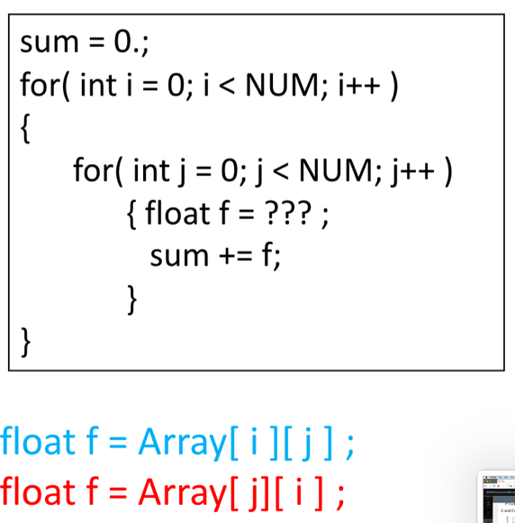

A[0][1], A[0][2], A[0][3]

shows ***spatial* l**ocality, things that are accessed close in time are close in space. It does not show *temporal* locality because you have not accessed the same thing more than once.

Here's an example that shows temporal locality

A[1], A[2000], A[1], A[1], A[2000], A[30], A[30], A[2000], A[30], A[2000]

Direct Memory Acces:

-devices can directly communicate without the use of programmed

instructions

Programmed I/O

-instructions to control devices; device registers; polling

•treating device registers as locations in the machine’s address

space

What are the steps performed by an OS to create a new process

-1) Assign a unique process identifier to the new process  
2) allocate space for the new process  
3) initialize the process control block  
4) set the appropriate linkages  
5) create or expand other data structures

What is the difference between an interrupt and a trap

-an interrupt occurs in the hardware and is external to the execution of the current instruction, it is used as a reaction to an asynchronous external event   
-a trap occurs in the software and the OS determines if the error or exception condition is fatal. it is caused by association with the execution of the current instruction and it's used to handle an error or an exception conditio

Give three examples of an interrupt.

-Clock interrupt   
-I/O interrupt  
-Memory fault

What is the difference between a mode switch and a process switch

-A mode switch may occur without changing the state of the process that is currently in the Running state. Whereas a process switch involves a state change - much more expensive

Chapter 2

what's the role of dispatcher

-To switch the processor from one process to another

why does processes have 2 suspended states

-To differentiate the processes that are suspended but ready to run, and ones that are suspended and blocked.

what are the states a process can be in

-new  
- ready  
- running  
- blocked  
- ready/suspended  
- blocked/suspended  
-exit

What is an instruction trace

-A sequence of instructions that execute for a process